
A 10

Sreenidhi Institute of Science & Technology
(An Autonomous Institution)
Code No: 101EC09/111EC09

B. TECH. II – Year II – Semester Examinations, January, 2014 (Supplementary)
PULSE AND DIGITAL CIRCUITS ( ECE & ECM )

Time: 3 Hours Max. Marks : 70

Note : No additional answer sheets will be provided.

Part-A (Objective Type)
Max.Marks:20

Answer all QUESTIONS.

1. Why is f₁ called the lower cut - off frequency of an RC high - pass filter? Write an expression for f₁.
2. Draw the RC low pass circuit response for square wave input for τ >> T and τ << T cases.
3. State clamping theorem and give its expression.
4. Draw the transfer characteristic of the following circuit.
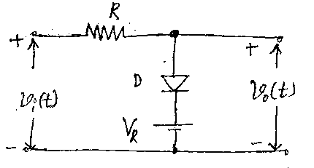
5. Define slope error, displacement error and transmission error.
6. What is the basic principle of miller time - base circuit?
7. What do you mean by symmetrical and asymmetrical triggering?
8. What are the applications of monostable and astable multivibrators?
9. What are the advantages and disadvantages of the unidirectional diode gate?
10. Define a positive and negative logic systems.
Part – B
Max. Marks: 50

ANSWER ANY FIVE QUESTIONS. EACH QUESTION CARRIES 10 MARKS.

1. With expressions and neat waveforms, explain the response of the RC low - pass filter to a square wave input.

2. a) With circuit diagram and transfer characteristics explain the emitter - coupled clipper. [6+4]
b) A 100 peak square wave with a period of 2 ms shown in figure is to be positively clamped at 25V. Draw the circuit diagram necessary for this purpose. Draw the output waveform.
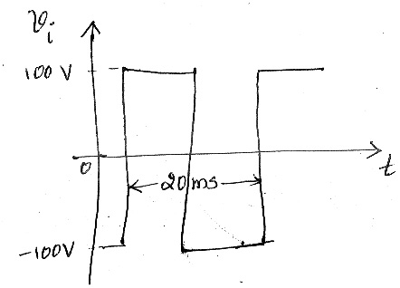
3. With neat circuit diagram, wave forms and expressions, explain two - transistor bootstrap voltage time - base circuit.
4. Draw the circuit diagram of a schmitt trigger circuit and explain its operations. Derive the expression for its UPT and LTP.
5. With a neat circuit diagram, base and collector wave forms, explain a collector - coupled monostable multivibrator. What are its applications.
6. a) Explain the operation of unidirectional sampling gate for multiple inputs.
b) Realize a 2-input AND gate using diodes and explain its operations with the help of functional table. [5+5]
7. a) Compare different logic families. [5+5]
b) What is a sampling gate? Explain how it is different from logic gates.
8. a) Explain how a transistor can be used as an electronic switch. [5+5]
b) Discuss the different methods of triggering a flip - flop. Explain the role of commutative capacitors in a binary circuit.
-- 00 -- 00 --

